IMAT2207 Online Workshop Week 16
In order to complete the work for this module you will be required to work in teams of 3-5 people.
Your team members must be in the same online session. There may be some option to allow students to change online sessions to work with friends, but we need to be careful of numbers. The module leader has final say on allowing switching sessions. I make no promises.
For this first session you need to organise yourselves into your teams, decide on a team name, select a topic for your system and set up your team meeting room on MS Teams.
- You will need to access the team spreadsheet for your online workshop available here…
https://demontfortuniversity-my.sharepoint.com/:f:/g/personal/mdean00_dmu_ac_uk/Eh2aQ1SAdptCqb6TZz3x9D8B9oVYawjeqr6LiG87JLuFXQ?e=noV06B
Sign in with your DMU account and you should see something like the following…
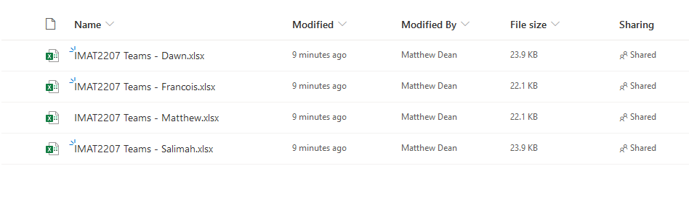
Open the spreadsheet belonging to your tutor and you should see this…
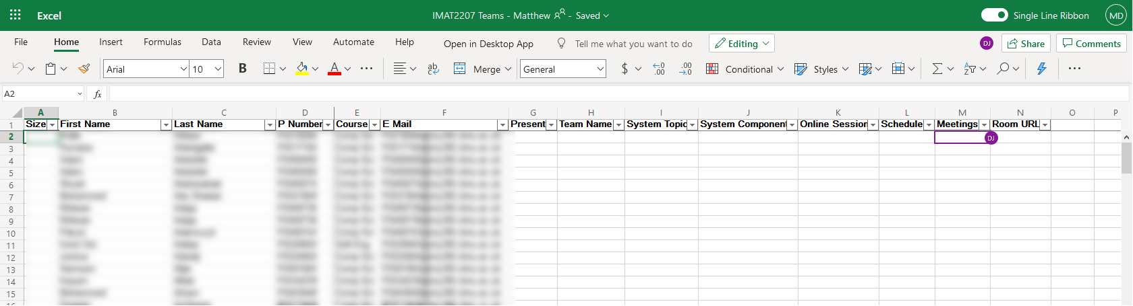
First, mark yourself as present in column G with a “x”. Once all the students have marked themselves as present your tutor will filter the that way you are able to see who is in the same workshop as you.
Use whatever communication tools you have available to see if you are able to form a team with the people you would like to work with (email addresses are visible in column F).
Once you have decided who you are working with you need to decide on a team name. This may be anything you like. Once you are happy enter this for each team member in column H.
Once everybody has a team name on the spreadsheet your tutor will likely update column K with the date and time of this workshop so that they know when you are all due to attend.

Creating your team meeting room
One team member needs to open up MS Team, the desktop App not the web version.
Under the calendar tab…
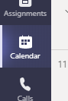
Find the button meet now…
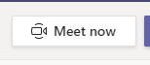
Press this to set up a new meeting and set a name for your meeting room…

Join the meeting by pressing join now…

This will open the meeting room…
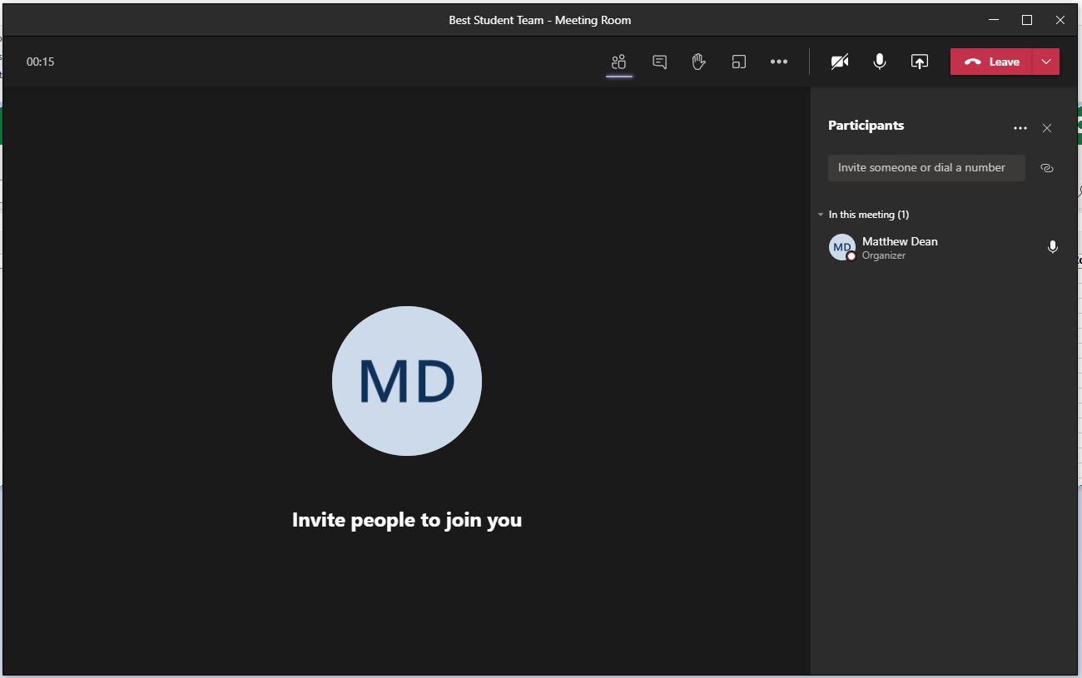
Make sure that the participants tab is open by clicking the following icon…
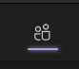
You should see something like this to the right of the meeting room…
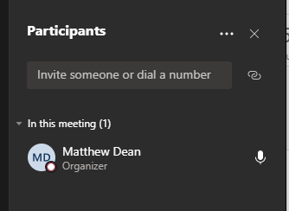
Press the link icon to the right to copy a link to the meeting to the clipboard…
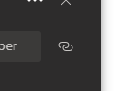
TBH the easiest way to do the next task is in notepad.
Open notepad and paste the HTML in for the link like so…
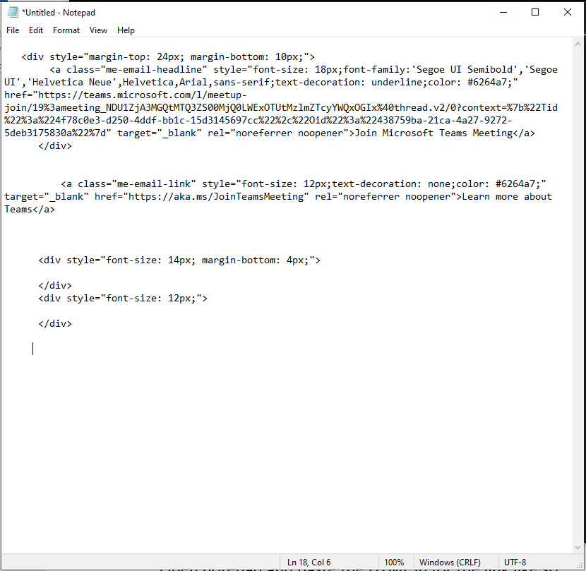
You want to extract the meeting room’s URL which is this HTML…
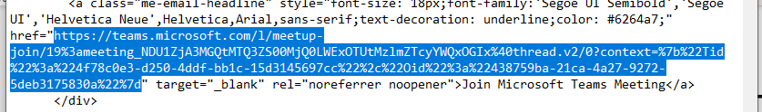
Copy this HTML and send it to your team members.
By pasting it into a browser you should all now have access to your team’s meeting room.
Once you are happy this is working paste the URL into column N of the workshop spreadsheet for each team member.
Also keep a copy of the URL so that you all have access to the meeting room in future.
Your tutor will use this meeting room to assess your progress with the work for the module.

What next?
Start working though the document Getting Started on the Assignment…
http://www.cse.dmu.ac.uk/~mjdean/notes/modules/projects/IMAT2207/2021/content/Lab%2016a%20Getting%20Started%20on%20the%20Assessment/Getting%20Started%20on%20the%20Assessment.docx
Once you have decided on a topic for your system and allocated individual subsystems you will need to enter these on the spreadsheet.

